LRDI - Ratio and proportion

https://www.facebook.com/events/150756915587022/150766318919415

1st graph: Breakage of Hill products in 2002  
2nd Graph: sales in 2002 (150Cr)  
3rd graph:sales in 2003 (375Cr)

Time:10-12 min

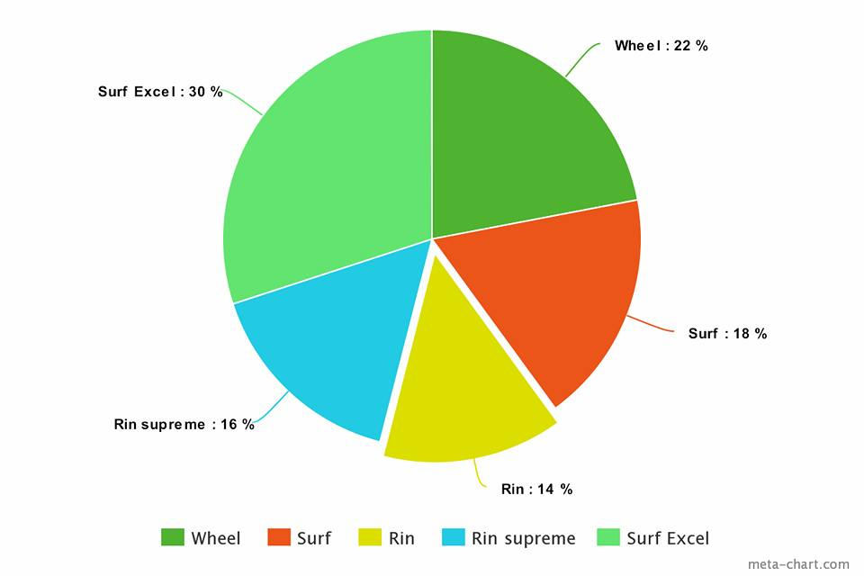

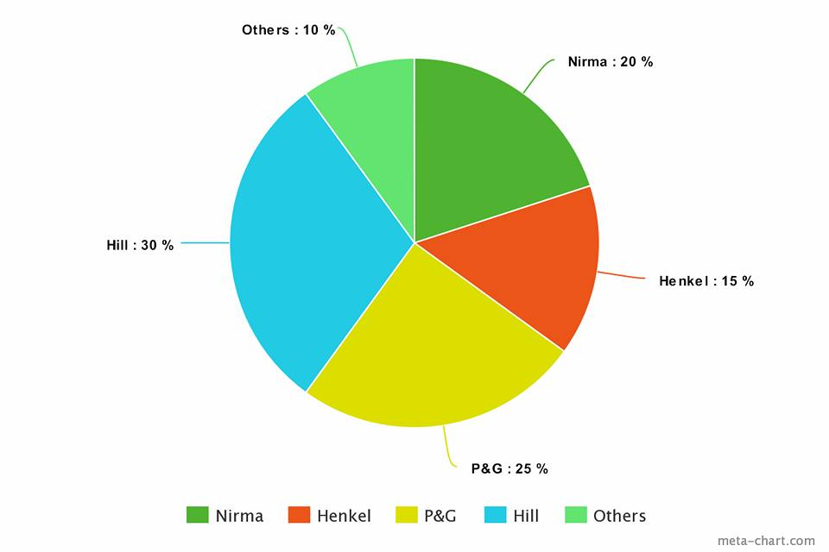

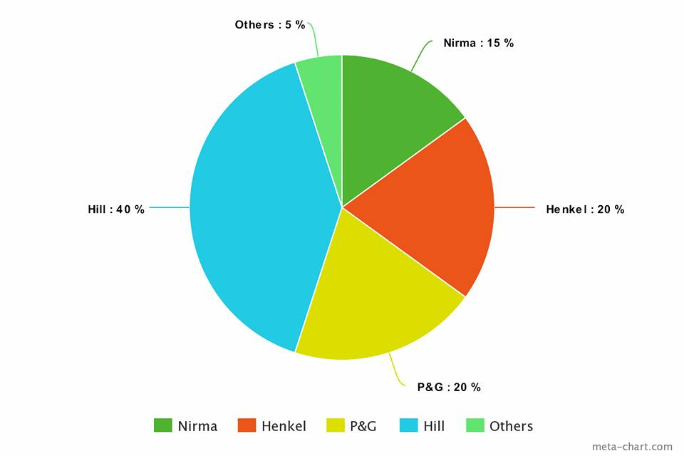

1.what is %increase of sales of overall deregent market in 2003 over 2002

2.which of the following is recorded the minimum growth of sales in year 2003 over 2002?  
A.P&G  
B.Hill  
C.Henkel  
D.nirma  
E.others

3.what is the growth rate of hill detergent?

4.what is the ratio of sales of P&G in 2003 to it's sales in year 2002?  
A.5:2  
B.3:2  
C.1:2  
D.2:5  
E.2:1

5.if the sales value of the companies in 2002 would have been higher by 10%,then the detergent market would have been larger by how much value?  
A.15cr  
B.25cr  
C.10cr  
D.30cr

6.If they year 2001 the expenditure of HILL is 30Cr and it increase by 30% every year then what are the values of the following in the year 2002 for HILL?  
Profit,profit%,

7.If the total sales of detergent market is doubled in 2002 and in 2003,then what will be ratio of sales of Nirma for 2003 to 2002?  
A.7:8  
B.16:5  
C.15:8  
D.12:7

What is the market share of surf excel in the detergent market in 2002?  
A.7.5%  
B.12%  
C.9%  
D.14.5%

What is the profit earned by Henkel for 2002?  
Assume profit %=25  
A.9cr  
B.15cr  
C.4.5cr  
D.6.5cr

In 2003, expenditure of P&G is 80% of sales of P&G in that year.what is the profit % in 2004 if both the sales and expenditure increases by 10% in 2004?  
A.10%  
B.20%  
C.25%  
D.33.33%

Solution of Post-1  
It was a very conceptual set of change and %change.rake your time to understand the concept.all the next sets of Questions will be based on it.

https://www.youtube.com/watch?v=cV82fb9z79w&feature=youtu.be

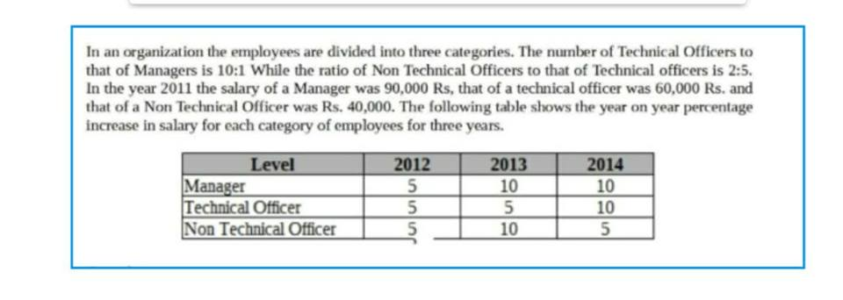

The average percentage increase of salary of which cateogry was the least over the three years?  
A.Manager  
B.Technical officer  
C.Non-technical officer  
D.Both B&C

What is the increase in salary of manager in 2014 over 2013?

https://www.youtube.com/watch?v=VXunH2PTPyU&feature=youtu.be

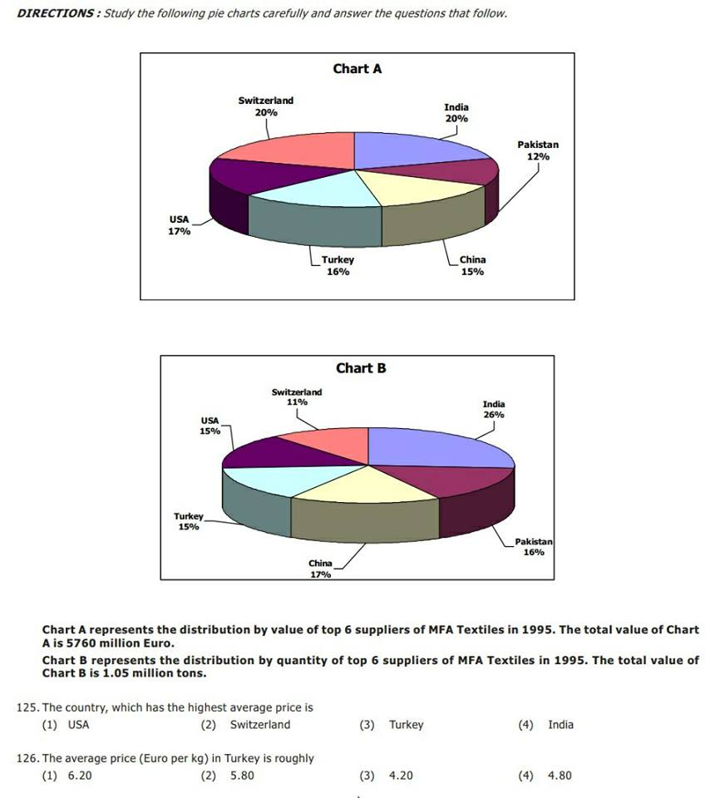

https://www.youtube.com/watch?v=HO5Rv1sr2Ok&feature=youtu.be

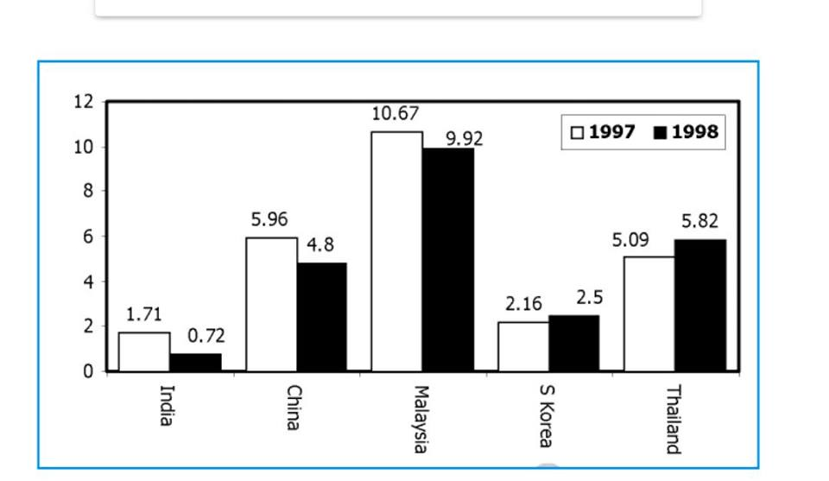

The country with the largest change in FEI in 1998 relative to its FEI in 1997, is  
(1) India (2) China (3) Malaysia (4) Thailand

Based on the data provided, it can be concluded that  
1.absolute value of foreign equity inflows in 1998 was higher than that in 1997 for both Thailand and South Korea.  
  
2.absolute value of foreign equity inflows was higher in 1998 for Thailand and lower for Chaina than the corresponding values in 1997.  
  
3.absolute value of foreign equity inflows was lower in 1998 for both India and China than the corresponding value in 1997.  
4.none of the above can be inferred.

It is known that China’s GDP in 1998 was 7% higher than its value in 1997, while India’s GDP grew by 2% during the same period. The GDP of South Korea, on the other hand, fell by 5%. Which of the following statements is/are true?  
Foreign equity inflows to China were higher in 1998 than in 1997.  
Foreign equity inflows to China were lower in 1998 than in 1997.  
Foreign equity inflows to India were higher in 1998 than in 1997.  
Foreign equity inflows to South Korea decreased in 1998 relative to 1997.  
Foreign equity inflows to South Korea increased in 1998 relative to 1997.  
(1) I, III & IV (2) II, III & IV (3) I, III&V (4) II &V

China’s foreign equity inflows in 1998 were 10 times that into India. It can be concluded that  
1.China’s GDP in 1998 was 40% higher than that of India.  
2.China’s GDP in 1998 was 70% higher than that of India.  
3.China’s GDP in 1998 was 50% higher than that of India.  
4.No inference can be drawn about relative magnitudes of China’s and India’s GDPs.

Solution to post 4  
It was an easy to moderate set.Bit calculative and have to use approximation.never find the exact value unless asked.

The table shows trends in external transactions of Indian corporate sector during the period 1993-94 to 1997-98. In addition, following definitions hold good.  
Salesi, Importsi, and Exportsi respectively denote the sales, imports and exports in year i.  
Deficit in year i, Deficiti = Importsi - Exportsi.  
Deficit Intensity in year i, DIi = Deficiti / Salesi.  
Growth rate of deficit intensity in year i, GDIi = (DIi - DI i_1)/DI i_1.  
Further, note that all imports are classified as either raw material or capital goods.  
Trends in External Transactions of Indian Corporate Sector

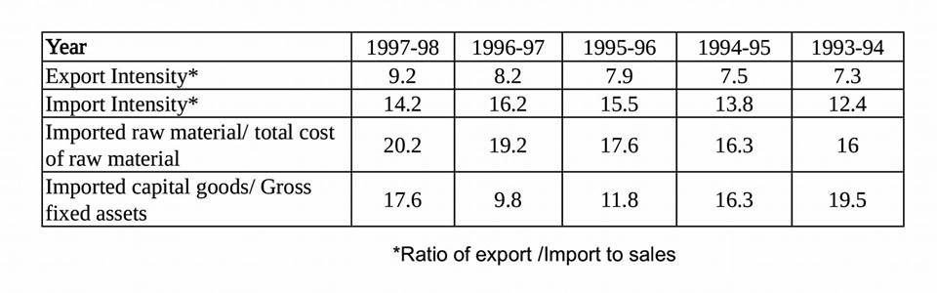

The highest growth rate in deficit intensity was recorded in  
(1) 1994-95 (2) 1995-96 (3) 1996-97 (4) 1997-98

The value of the highest growth rate in deficit intensity is approximately  
(1) 8.45% (2) 2.15% (3) 33.3% (4) 23.5%

In 1997-98 the total cost of raw materials is estimated as 50% of sales of that year. The turn over of Gross fixed assets, defined as the ratio of sales to Gross fixed assets, in 1997-98 is, approximately  
(1) 3.3 (2) 4.3  
(3) 0.33 (4) not possible to determine

Which of the following statements can be inferred to be true from the given data?  
1.During the 5 year period between 1993-94 and 1997-98, exports have increased every year.  
  
2.During the 5 year period between 1993-94 and 1997-98, imports have decreased every year.  
  
3.Deficit in 1997-98 was lower than that in 1993-94.  
  
4.Deficit intensity has increased every year between 1993-94 and 1996-97

https://www.youtube.com/watch?v=uFyFog1wNK0&feature=youtu.be

Simple Happiness index (SH I) of a country is computed on the basis of three parameters: social support ,(S), freedom to life choices (H and corruption perception (C)• Each of these three parameters is measured on a scale of 0 to 8 ra integers only). A country is the categorised based on the total score obtained by surruning the scares otall the three parameters, as shown in the following table:

Following diagram depicts the frequency distribution, of the scores in S, F and C of 10 countries - Arra, Bengal, Calla, Delma, Eppa, Varsa, Wanna, Xanda, Yanga and Zooma:

(Read the rest of the questions in the picture)

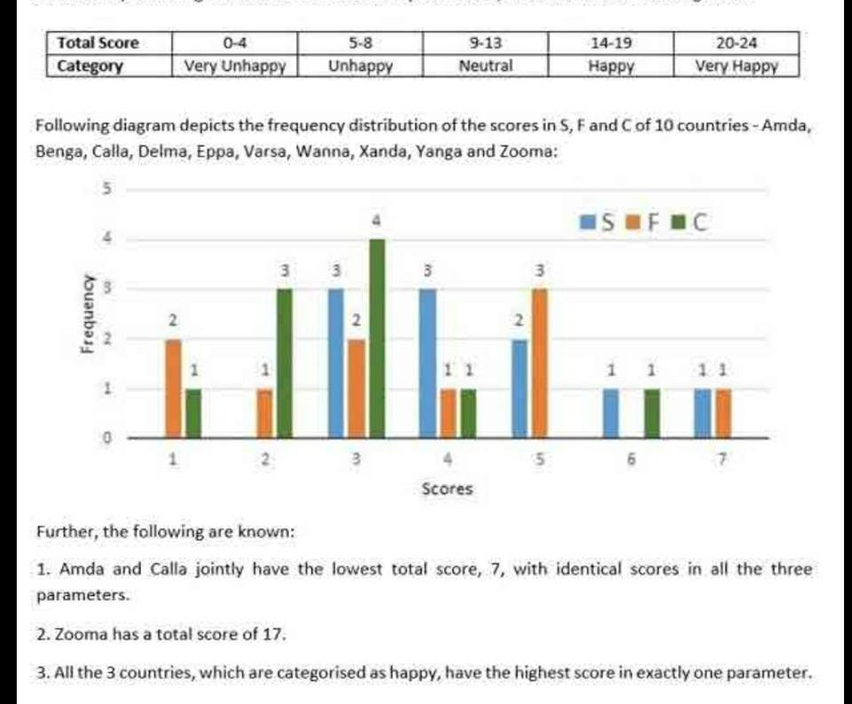

What is Amda's score in F?

What is Zooma's score in S ?

Benga and Delma, two countries categoriz,ed as happy, are tied with the same total score. What is the maximum score they can have?  
Options :  
14  
15  
16  
17

If Benga scores 16 and Delma scores 15, then what is the maximum number of countries with a. score of 13?  
0  
1  
2  
3

In an 8 X 8 chessboard a queen placed anywhere can attack another piece if the piece is present in the same row, or in the same column or in any diagonal position in any possible 4 directions, provided there is no other piece in between in the path from the queen to that piece.  
The columns are labelled a to h (left to right) and the rows are numbered 1 to 8 (bottom to top). The position of a piece is given by the combination of column and row labels. For example, position c5 means that the piece is in the c column and 5th row.

If the other pieces are only at positions al, a3, b4, d7, h7 and h8, then from how many positions the queen cannot attack any of the pieces?  
0  
3  
4  
6

If the queen is at c5, and the other pieces at positions c2, g1,g3., g5 and a3, how many are under attack by the queen? There are no other pieces on the board.  
Options :  
A.1  
B.2  
C.4  
D.5

If the other pieces are only at positions a1, a3b4, d7, h7 and h8, then which of the following positions of the queen results in the maximum number of pieces being under attack?  
A.0  
B.3  
C.4  
D.6

Suppose the queen is the only piece on the board and it is at position d5.  
In how many positions can another piece be placed on the board such that it is safe from attack from the queen?  
32  
35  
36  
37

A cricket match is played between two teams, representing two different countries on a ground located in either of the two countries. Suppose a cricket match is played between teams A and B in the country of team A, it is said that team A is playing at ‘home’ and team B is playing ‘away’. It is known that, in total, 2000 one-day international cricket matches were played during a certain period. It is known that in each match, one team won and the other team lost i.e. there were no drawn matches. Australia, India, South Africa, New Zealand, England and Sri Lanka are the only countries that play cricket. It is known that all the countries played exactly 50% of their matches at home.

Pie Chart 1 below shows the percent break-up of cricket matches played by each of the six teams out of the sum total of the matches played by all the teams.

Pie Chart 2 below shows the percent break-up of cricket matches won by each

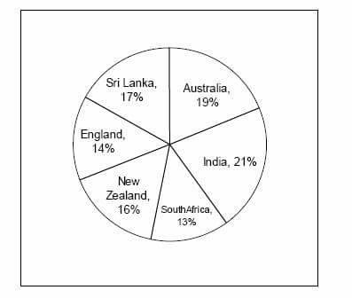

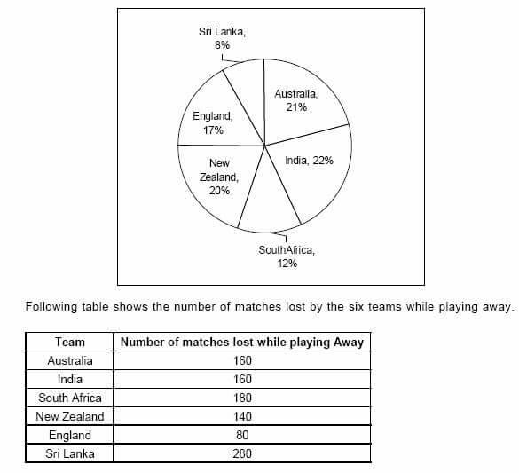

LRDI is not tough jitna log hall karte Hain...

Solve this actual CAT16 LR set.

A coding system performs following operations on the alphabets. C0 = A letter at position odd is substituted with the next letter while the letter at even position is substituted with previous letter. After the substitution, the whole word is written in reverse order. For example coding of the word INDIA will be as follows: I substituted with J, N with M and so on to form the word JMEHB and then the word is written in the reverse order to form BHEMJ.  
Cn for n = 1,2,3…… the operation is that every letter is written with n steps ahead. For example ASIA when performed with C1 will be BTJB and then it will also be written in reverse order to form the word BJTB

Top of Form

[**Like**](https://www.facebook.com/events/150756915587022/150798968916150/?notif_t=admin_plan_mall_activity&notif_id=1518029477921146)

1.What will be the code of the word MADAM if the operations C0 and C3 are performed?

QCHCQ

2. If operations C0,C1,C3 are performed the word becomes IRFKIL. What is the original word?

GFFCMF